John Heberle-b1854-d1913-FortWorthTX
Birth: | Feb. 24, 1854, Germany
Death: | Apr. 29, 1913  Tarrant County  Texas, USA
s/o Anthony Heberle and May/Mary Spair
From the Dallas Morning News, Wednesday, April 30, 1913:
Fort Worth, Tex., April 29. -- John Heberle, aged 60 years, who resided on the White Settlement road, three miles northwest of the city, died at a local hospital late last night. Heberle sustained a slight abrasion on the right hand a week ago and it is thought his death resulted from blood poisoning. The deceased is survived by his widow and two daughters. Funeral services will be held tomorrow morning at 10 o'clock at St. Patrick's Roman Catholic Church, Rev. Father Nolan officiating. Burial will be in Calvary Cemetery.
(Obituary courtesy of BeNotForgot)
Family links:
Spouse:
Josephine Heberle (1849 - 1924)
Note: ssw Josephine Heberle
Burial:
Greenwood Memorial Park and Mausoleum
Fort Worth
Tarrant County
Texas, USA
Plot: Section 1E
Created by: JCF
Record added: Jul 15, 2010
Find A Grave Memorial# 55004232

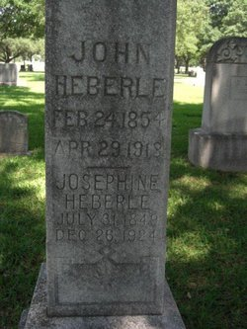
Added by: Carol
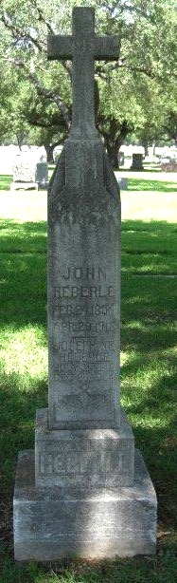
Added by: Carol

